Q1A: ANS:

SELECT SOD.SalesOrderID, P.Name, PS.Name, PC.Name, SOD.UnitPrice, SOD.UnitPriceDiscount, SOD.LineTotal

FROM Sales.SalesOrderDetail SOD

INNER JOIN Production.Product P

ON SOD.ProductID = P.ProductID

INNER JOIN Production.ProductSubcategory PS

ON P.ProductSubcategoryID =PS.ProductSubcategoryID

INNER JOIN Production.ProductCategory PC

ON PS.ProductCategoryID = PC.ProductCategoryID

ORDER BY 2 ASC

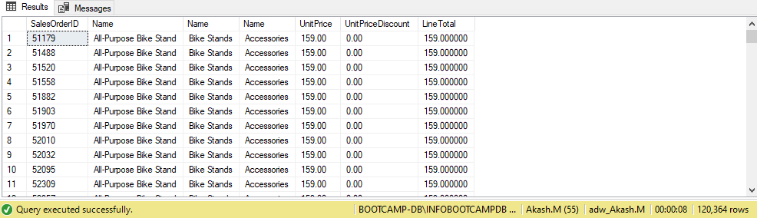

Q1B: ANS:

SELECT P.ProductID, P.Name, PS.ProductSubcategoryID, PS.Name, PC.ProductCategoryID, PC.Name

FROM Production.Product P

LEFT JOIN Production.ProductSubcategory PS

ON P.ProductSubcategoryID = PS.ProductSubcategoryID

LEFT JOIN Production.ProductCategory PC

ON PS.ProductCategoryID = PC.ProductCategoryID

ORDER BY 2

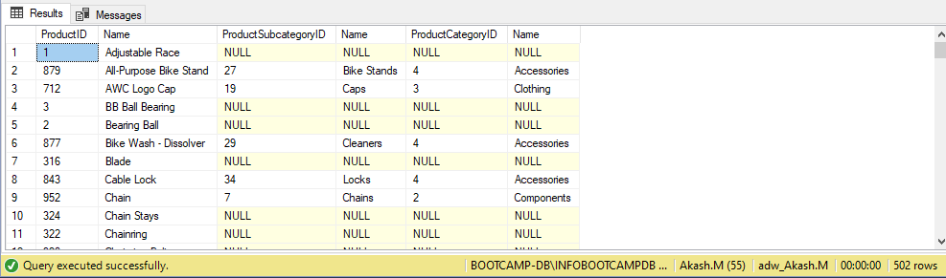

Q2: ANS:

SELECT PC.Name, SOH.OrderDate, SUM(SOH.SubTotal) AS SubTotal

FROM Production.Product P

INNER JOIN Production.ProductSubcategory PS

ON P.ProductSubcategoryID = PS.ProductSubcategoryID

INNER JOIN Production.ProductCategory PC

ON PS.ProductCategoryID = PC.ProductCategoryID

INNER JOIN Sales.SalesOrderDetail SOD

ON P.ProductID = SOD.ProductID

INNER JOIN Sales.SalesOrderHeader SOH

ON SOD.SalesOrderID = SOH.SalesOrderID

GROUP BY PC.Name, SOH.OrderDate

HAVING SOH.OrderDate BETWEEN '12-1-2003' AND '12-31-2003'

ORDER BY 2

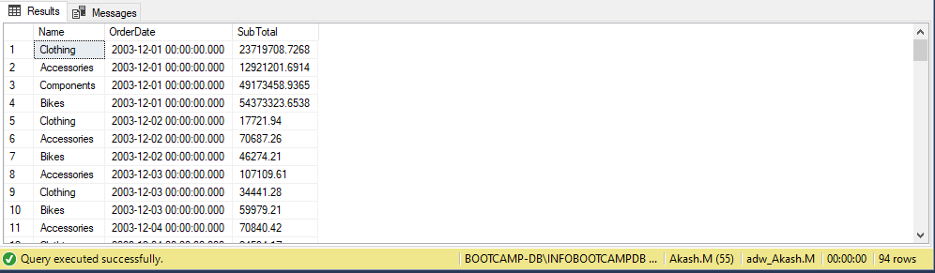

Q3: ANS:

SELECT SOH.SalesOrderID, SR.Name, SR.ReasonType, SOH.ShipDate, SOH.SubTotal, SOH.TaxAmt, SOH.Freight, SOH.TotalDue

FROM Sales.SalesOrderHeader SOH

INNER JOIN Sales.SalesOrderHeaderSalesReason SOHSR

ON SOH.SalesOrderID = SOHSR.SalesOrderID

INNER JOIN Sales.SalesReason SR

ON SOHSR.SalesReasonID = SR.SalesReasonID

WHERE SR.Name <> 'Manufacturer'AND SR.Name <> 'Quality'

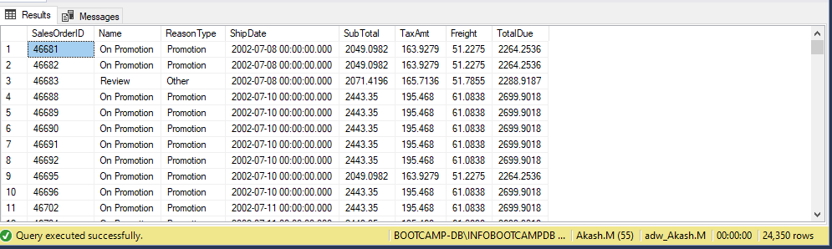

Q4: ANS:

SELECT DISTINCT P.Name

FROM Production.Product P

INNER JOIN Sales.SpecialOfferProduct SOP

ON P.ProductID = SOP.ProductID

INNER JOIN Sales.SpecialOffer SO

ON SOP.SpecialOfferID = SO.SpecialOfferID

WHERE SO.DiscountPct <= 0.45 AND P.Name NOT LIKE 'R%'

ORDER BY Name DESC

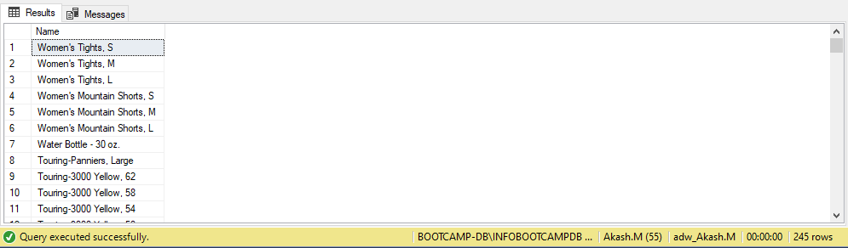

Q5: ANS:

SELECT Name

FROM Production.Product

WHERE Name LIKE '%[0-9]%' OR Name LIKE '%[-,/]%'

ORDER BY 1

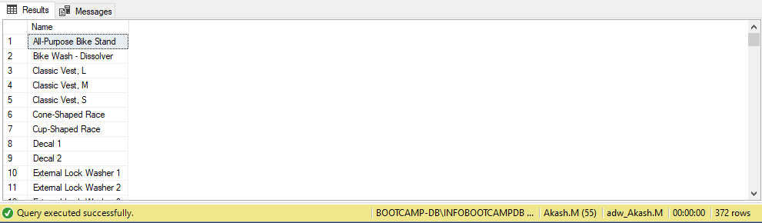

Q6: ANS:

SELECT SP.Name, SR.TaxRate, SR.Name

FROM Sales.SalesTaxRate SR

INNER JOIN Person.StateProvince SP

ON SR.StateProvinceID = SP.StateProvinceID

WHERE SR.TaxRate = (SELECT MAX(TaxRate) FROM Sales.SalesTaxRate)

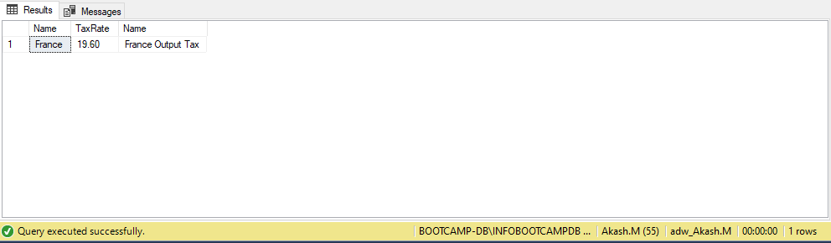

Q7: ANS:

SELECT ST.Name, PC.Name, CAST(SUM(SOD.LineTotal) AS NUMERIC(10,2))

FROM Sales.SalesOrderHeader SOH

INNER JOIN Sales.SalesTerritory ST

ON SOH.TerritoryID = ST.TerritoryID

INNER JOIN Sales.SalesOrderDetail SOD

ON SOH.SalesOrderID = SOD.SalesOrderID

INNER JOIN Production.Product P

ON SOD.ProductID = P.ProductID

INNER JOIN Production.ProductSubcategory PS

ON P.ProductSubcategoryID = PS.ProductSubcategoryID

INNER JOIN Production.ProductCategory PC

ON PS.ProductCategoryID = PC.ProductCategoryID

GROUP BY ST.Name, PC.Name

ORDER BY 1,2

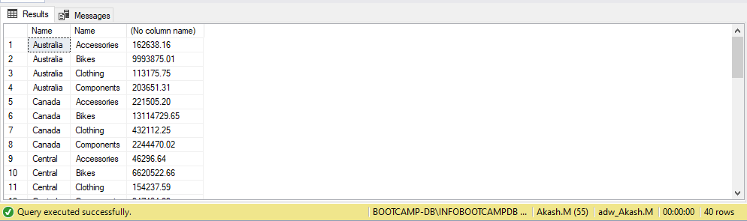

Q8: ANS:

with cte as(

select

CASE

WHEN DATEDIFF(YEAR,E.HireDate,GETDATE()) < 15 THEN 'Less than 15'

WHEN DATEDIFF(YEAR,E.HireDate,GETDATE()) BETWEEN 15 AND 18 THEN 'greater than 15 and less than 18'

WHEN DATEDIFF(YEAR,E.HireDate,GETDATE()) > 18 THEN 'greater than 18'

END AS Experience ,

SP.SalesYTD AS [Total Sales],

E.EmployeeID AS Employee_ID

from HumanResources.Employee E

LEFT JOIN Sales.SalesPerson SP

ON SP.SalesPersonID=E.EmployeeID

)

SELECT Experience,SUM([Total Sales]) AS [Total Sales],COUNT(Employee_ID) as [Number Of Employees]

FROM cte

GROUP BY Experience

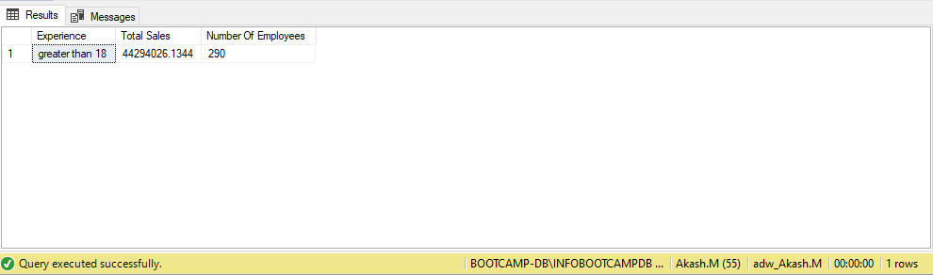

Q9: ANS:

SELECT PC.Name, AVG(SOD.OrderQty) AS [Unit Sold]

FROM Sales.SalesOrderHeader SOH

INNER JOIN Sales.SalesOrderDetail SOD

ON SOH.SalesOrderID = SOD.SalesOrderID

INNER JOIN Production.Product P

ON SOD.ProductID = P.ProductID

INNER JOIN Production.ProductSubcategory PS

ON P.ProductSubcategoryID = PS.ProductSubcategoryID

INNER JOIN Production.ProductCategory PC

ON PS.ProductCategoryID = PC.ProductCategoryID

WHERE YEAR(SOH.OrderDate) = 2003 AND MONTH(SOH.OrderDate) IN (5)

GROUP BY PC.Name

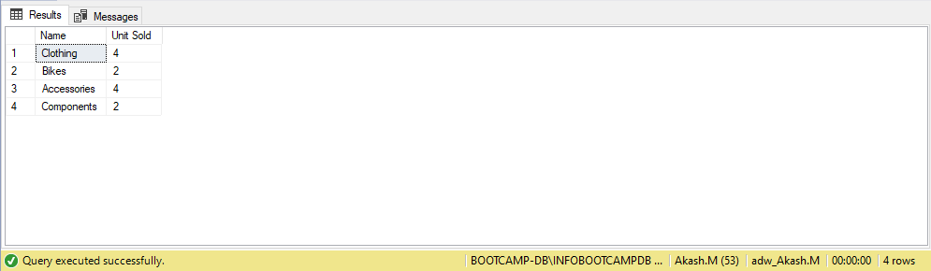

Q10A: ANS:

WITH CLOTHES AS (

    SELECT YEAR(SOH.ShipDate) AS Year, MONTH(SOH.ShipDate) AS Month, SUM(SOD.OrderQty) AS CNT_C

    FROM Sales.SalesOrderHeader SOH

    INNER JOIN Sales.SalesOrderDetail SOD

    ON SOH.SalesOrderID = SOD.SalesOrderID

    INNER JOIN Production.Product P

    ON SOD.ProductID = P.ProductID

    INNER JOIN Production.ProductSubcategory PS

    ON P.ProductSubcategoryID = PS.ProductSubcategoryID

    INNER JOIN Production.ProductCategory PC

    ON PS.ProductCategoryID = PC.ProductCategoryID

    WHERE YEAR(SOH.ShipDate) = 2003 AND PC.Name = 'Clothing'

    GROUP BY YEAR(SOH.ShipDate), MONTH(SOH.ShipDate), PC.Name

),

BIKE AS (

    SELECT YEAR(SOH.ShipDate) AS Year, MONTH(SOH.ShipDate) AS Month, SUM(SOD.OrderQty) AS CNT_B

    FROM Sales.SalesOrderHeader SOH

    INNER JOIN Sales.SalesOrderDetail SOD

    ON SOH.SalesOrderID = SOD.SalesOrderID

    INNER JOIN Production.Product P

    ON SOD.ProductID = P.ProductID

    INNER JOIN Production.ProductSubcategory PS

    ON P.ProductSubcategoryID = PS.ProductSubcategoryID

    INNER JOIN Production.ProductCategory PC

    ON PS.ProductCategoryID = PC.ProductCategoryID

    WHERE PC.Name = 'Bikes' AND YEAR(SOH.OrderDate) = 2003

    GROUP BY YEAR(SOH.ShipDate), MONTH(SOH.ShipDate), PC.Name

)

SELECT C.Year, C.Month, C.CNT_C, B.CNT_B

FROM CLOTHES C

INNER JOIN BIKE B

ON C.Month = B.Month

WHERE C.CNT_C < B.CNT_B

ORDER BY 2

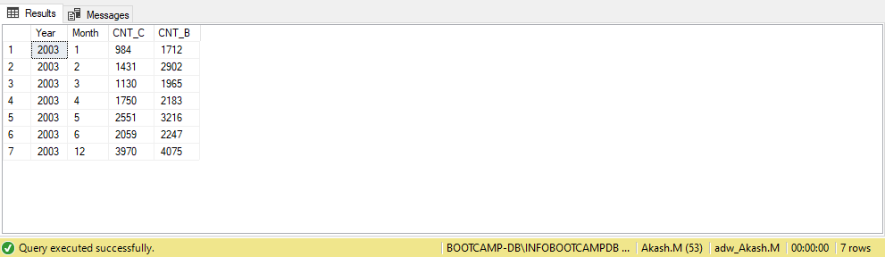

Q10B: ANS:

SELECT LEFT(P.Name, 10), PD.Description

FROM Production.Product P

INNER JOIN Production.ProductModel PM

ON P.ProductModelID = PM.ProductModelID

INNER JOIN Production.ProductModelProductDescriptionCulture PC

ON PM.ProductModelID = PC.ProductModelID

INNER JOIN Production.ProductDescription PD

ON PC.ProductDescriptionID = PD.ProductDescriptionID

order by P.Name

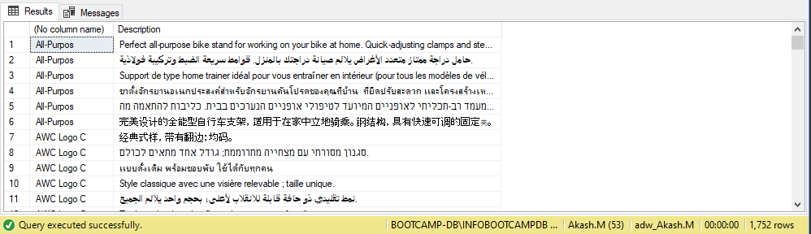

Q11: ANS:

SELECT LEFT(P.Name,10) as Broken_Product_Name,

PD.[Description],

(len(P.Name) - len(left(P.Name,10))) as No_of_characters_deleted -- gives number of characters deleted

FROM Production.Product P

JOIN Production.ProductModelProductDescriptionCulture PM

ON P.ProductModelID = PM.ProductModelID

JOIN Production.ProductDescription PD

ON PM.ProductDescriptionID = PD.ProductDescriptionID

ORDER BY P.Name;

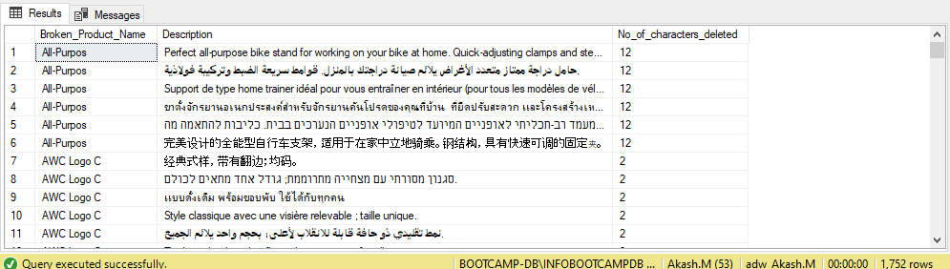

Q12: ANS:

SELECT SUM(SOD.OrderQty) AS Total_Products_Sold

FROM HumanResources.Employee E

JOIN Sales.SalesPerson SP

ON E.EmployeeID = SP.SalesPersonID

JOIN Sales.SalesOrderHeader SOH

ON SP.SalesPersonID = SOH.SalesPersonID

JOIN Sales.SalesOrderDetail SOD

ON SOH.SalesOrderID = SOD.SalesOrderID

WHERE E.MaritalStatus ='M'

AND ((DATEDIFF(MM,E.BirthDate,GETDATE())/12) BETWEEN 40 AND 50)

AND SOD.ModifiedDate BETWEEN '2003-07-01' AND '2003-09-30'

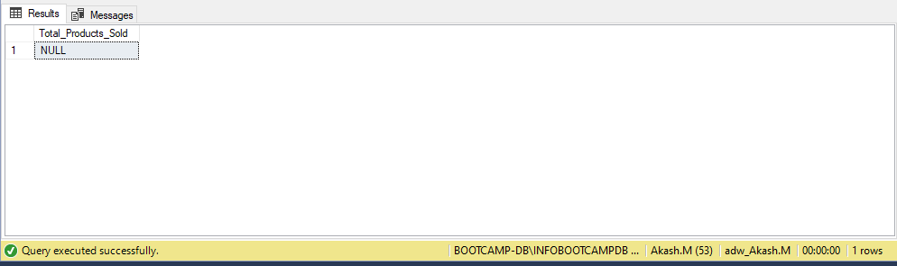

Q13: ANS:

SELECT COUNT(SC.CustomerID) AS "Count_of_Customers"

FROM (SELECT SOH.CustomerID,

COUNT(DISTINCT(PSC.ProductCategoryID)) AS [Count]

FROM Sales.Customer C

JOIN Sales.SalesOrderHeader SOH

ON C.CustomerID = SOH.CustomerID

JOIN Sales.SalesOrderDetail SOD

ON SOH.SalesOrderID = SOD.SalesOrderID

JOIN Production.Product P

ON SOD.ProductID = P.ProductID

JOIN Production.ProductSubcategory PSC

ON P.ProductSubcategoryID = PSC.ProductSubcategoryID

JOIN Production.ProductCategory PC

ON PSC.ProductCategoryID = PC.ProductCategoryID

GROUP BY SOH.CustomerID) AS SC WHERE SC.[Count]=4

GROUP BY SC.[Count]

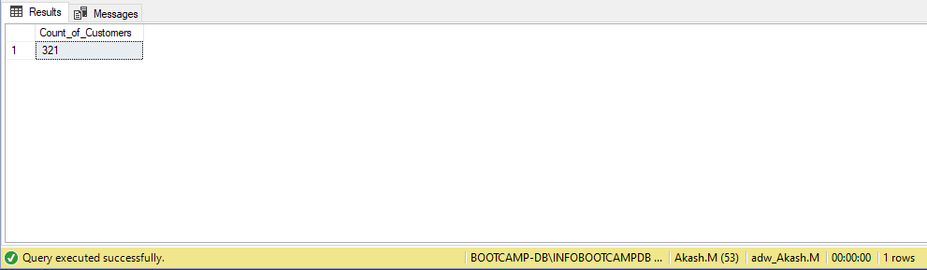

Q14: ANS:

WITH Bike(Category, TotalSales ) -- calculates total sales of Bike

AS ( SELECT PC.Name AS "Category",

SUM(SOD.LineTotal) AS "Sales Total"

FROM Sales.SalesOrderHeader SOH

JOIN Sales.SalesOrderDetail SOD

ON SOH.SalesOrderID = SOD.SalesOrderID

JOIN Production.Product P

ON SOD.ProductID = P.ProductID

JOIN Production.ProductSubcategory PSC

ON P.ProductSubcategoryID = PSC.ProductSubcategoryID

JOIN Production.ProductCategory PC

ON PSC.ProductCategoryID = PC.ProductCategoryID

WHERE PC.Name = 'Bikes' AND SOH.OrderDate LIKE '%2004%' AND MONTH(SOH.OrderDate) ='06'

GROUP BY PC.Name ),

Accessories(Category, TotalSales ) AS ( SELECT PC.Name AS "Category",

SUM(SOD.LineTotal) AS "TotalSales"

FROM Sales.SalesOrderHeader SOH

JOIN Sales.SalesOrderDetail SOD

ON SOH.SalesOrderID = SOD.SalesOrderID

JOIN Production.Product P

ON SOD.ProductID = P.ProductID

JOIN Production.ProductSubcategory PSC

ON P.ProductSubcategoryID = PSC.ProductSubcategoryID

JOIN Production.ProductCategory PC

ON PSC.ProductCategoryID = PC.ProductCategoryID

WHERE PC.Name = 'Accessories' AND SOH.OrderDate LIKE '%2004%' AND MONTH(SOH.OrderDate) ='06'

GROUP BY PC.Name )

SELECT b.Category,b.TotalSales,

CAST((b.TotalSales/SUM(SOD.LineTotal))*100 AS DECIMAL(10,2)) "Percent to Total" --total sales of bikes/total sales *100 gives percentage

FROM Bike b, Sales.SalesOrderHeader SOH

JOIN Sales.SalesOrderDetail SOD

ON SOH.SalesOrderID = SOD.SalesOrderID

WHERE SOH.OrderDate LIKE '%2004%' AND MONTH(SOH.OrderDate) ='06'

GROUP BY b.Category,b.TotalSales

UNION

SELECT a.Category,a.TotalSales,

CAST((a.TotalSales/SUM(SOD.LineTotal))*100 AS DECIMAL(10,2)) "Percent to total"

FROM Accessories a,Sales.SalesOrderHeader SOH

JOIN Sales.SalesOrderDetail SOD

ON SOH.SalesOrderID = SOD.SalesOrderID

WHERE SOH.OrderDate LIKE '%2004%' AND MONTH(SOH.OrderDate) ='06'

GROUP BY a.Category,a.TotalSales;

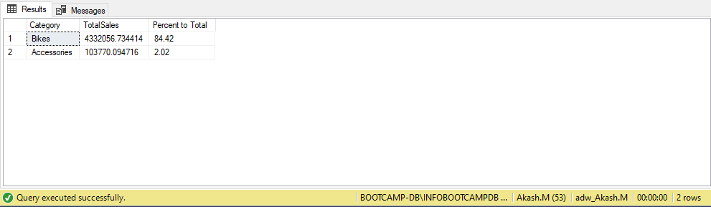

Q15: ANS:

WITH cte

AS (

SELECT SUM(SOD.LineTotal) AS "TotalSale" -- total sales grouped by each category

FROM Sales.SalesOrderDetail SOD

INNER JOIN Production.Product P

ON SOD.ProductID = P.ProductID

INNER JOIN Production.ProductSubcategory PSC

ON PSC.ProductSubcategoryID = P.ProductSubcategoryID

INNER JOIN Production.ProductCategory PC

ON PSC.ProductCategoryID = PC.ProductCategoryID

INNER JOIN Sales.SalesOrderHeader SOH

ON SOH.SalesOrderID = SOD.SalesOrderID

WHERE YEAR(SOH.OrderDate) = 2003

AND

DATENAME(MONTH,SOH.[OrderDate]) IN ('April','May' ,'June')

)

SELECT PC.Name Category,

CAST(((SUM(SOD.LineTotal)/CJ.TotalSale) * 100) AS decimal(10,2)) AS Sales -- rounded to two decimal places

FROM Sales.SalesOrderDetail SOD

CROSS JOIN cte CJ

INNER JOIN Production.Product P

ON SOD.ProductID = P.ProductID

INNER JOIN Production.ProductSubcategory PSC

ON PSC.ProductSubcategoryID = P.ProductSubcategoryID

INNER JOIN Production.ProductCategory PC

ON PSC.ProductCategoryID = PC.ProductCategoryID

INNER JOIN Sales.SalesOrderHeader SOH

ON SOH.SalesOrderID = SOD.SalesOrderID

WHERE YEAR(SOH.OrderDate) = 2003

AND

DATENAME(MONTH,SOH.OrderDate) IN ('April','May', 'June')

GROUP BY PC.Name, CJ.TotalSale

ORDER BY Sales DESC

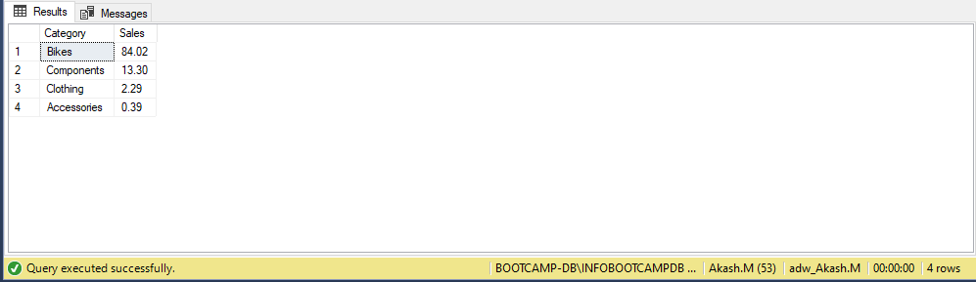

Q16: ANS:

SELECT TOP 1 *,(Maximum_Products_Sold-Minimum_Products_Sold) AS Difference_Between_Min_and_max

FROM

(SELECT PC.Name AS Product_Category,

MAX(SOD.OrderQty) AS Maximum_Products_Sold,

MIN(SOD.OrderQty) AS Minimum_Products_Sold -- stores diff between min and max

FROM Sales.SalesOrderDetail SOD

JOIN Production.Product P

ON SOD.ProductID = P.ProductID

JOIN Production.ProductSubcategory PSC

ON P.ProductSubcategoryID = PSC.ProductSubcategoryID

JOIN Production.ProductCategory PC

ON PSC.ProductCategoryID = PC.ProductCategoryID

WHERE YEAR(SOD.ModifiedDate) = 2003

group by PC.Name

)A

order by Difference_Between_Min_and_max DESC

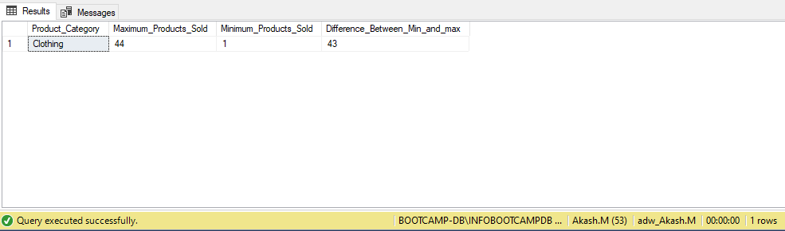

Q17: ANS:

SELECT PS.Name

FROM Sales.SalesOrderHeader SOH

JOIN Sales.SalesOrderDetail SOD

ON SOH.SalesOrderID = SOD.SalesOrderID

JOIN Production.Product P

ON SOD.ProductID = P.ProductID

JOIN Production.ProductSubcategory PS

ON P.ProductSubcategoryID = PS.ProductSubcategoryID

JOIN Production.ProductCategory PC

ON PS.ProductCategoryID = PC.ProductCategoryID

WHERE (MONTH(SOH.OrderDate) = 1 AND YEAR(SOH.OrderDate) = 2003) AND PC.Name = 'Clothing' -- gives products which were sold in 2003

GROUP BY PS.Name

INTERSECT

SELECT PS.Name

FROM Sales.SalesOrderHeader SOH

JOIN Sales.SalesOrderDetail SOD

ON SOH.SalesOrderID = SOD.SalesOrderID

JOIN Production.Product P

ON SOD.ProductID = P.ProductID

JOIN Production.ProductSubcategory PS

ON P.ProductSubcategoryID = PS.ProductSubcategoryID

JOIN Production.ProductCategory PC

ON PS.ProductCategoryID = PC.ProductCategoryID

WHERE (MONTH(SOH.OrderDate) = 2 AND YEAR(SOH.OrderDate) = 2004) AND PC.Name = 'Clothing' -- gives products which were sold in 2004

GROUP BY PS.Name

ORDER BY PS.Name

--WITHOUT INTERSECT

( SELECT PS.Name

FROM Sales.SalesOrderHeader SOH

JOIN Sales.SalesOrderDetail SOD

ON SOH.SalesOrderID = SOD.SalesOrderID

JOIN Production.Product P

ON SOD.ProductID = P.ProductID

JOIN Production.ProductSubcategory PS

ON P.ProductSubcategoryID = PS.ProductSubcategoryID

JOIN Production.ProductCategory PC

ON PS.ProductCategoryID = PC.ProductCategoryID

WHERE (MONTH(SOH.OrderDate) = 1 AND YEAR(SOH.OrderDate) = 2003) AND PC.Name = 'Clothing'

GROUP BY PS.Name )

EXCEPT

( SELECT PS.Name

FROM Sales.SalesOrderHeader SOH

JOIN Sales.SalesOrderDetail SOD

ON SOH.SalesOrderID = SOD.SalesOrderID

JOIN Production.Product P

ON SOD.ProductID = P.ProductID

JOIN Production.ProductSubcategory PS

ON P.ProductSubcategoryID = PS.ProductSubcategoryID

JOIN Production.ProductCategory PC

ON PS.ProductCategoryID = PC.ProductCategoryID

WHERE (MONTH(SOH.OrderDate) = 1 AND YEAR(SOH.OrderDate) = 2003) AND PC.Name = 'Clothing'

GROUP BY PS.Name

EXCEPT

SELECT PS.Name

FROM Sales.SalesOrderHeader SOH

JOIN Sales.SalesOrderDetail SOD

ON SOH.SalesOrderID = SOD.SalesOrderID

JOIN Production.Product P

ON SOD.ProductID = P.ProductID

JOIN Production.ProductSubcategory PS

ON P.ProductSubcategoryID = PS.ProductSubcategoryID

JOIN Production.ProductCategory PC

ON PS.ProductCategoryID = PC.ProductCategoryID

WHERE (MONTH(SOH.OrderDate) = 2 AND YEAR(SOH.OrderDate) = 2004) AND PC.Name = 'Clothing'

GROUP BY PS.Name)

ORDER BY PS.Name

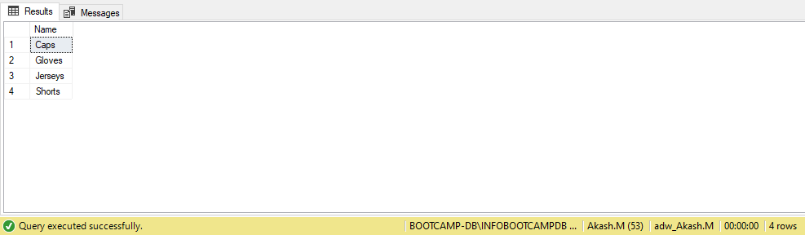

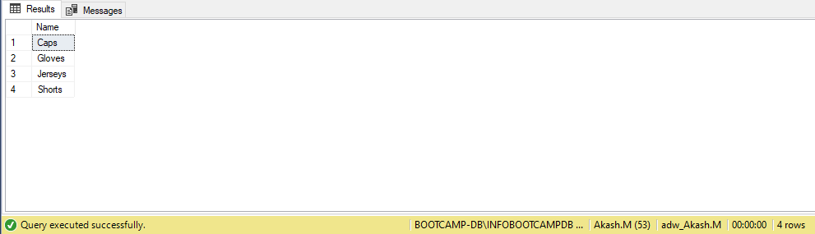

Q18: ANS:

WITH ABC AS

(

SELECT PC.Name AS "Product_Category",

P.Name "Product",

AVG(SOD.LineTotal) AS "Minimum_average_sale"

FROM Sales.SalesOrderHeader SOH

JOIN Sales.SalesOrderDetail SOD

ON SOD.SalesOrderID = SOH.SalesOrderID

JOIN Production.Product P

ON P.ProductID = SOD.ProductID

JOIN Production.ProductSubcategory PS

ON PS.ProductSubcategoryID= P.ProductSubcategoryID

JOIN Production.ProductCategory PC

ON PC.ProductCategoryID= PS.ProductCategoryID

WHERE YEAR(SOH.OrderDate) = 2003

GROUP BY PC.Name,P.Name

)

SELECT Product_Category,

Product,

Minimum_average_sale

FROM ABC a1

WHERE Minimum_average_sale = ( SELECT MIN(Minimum_average_sale)

FROM ABC

WHERE Product_Category= a1.Product_Category

)

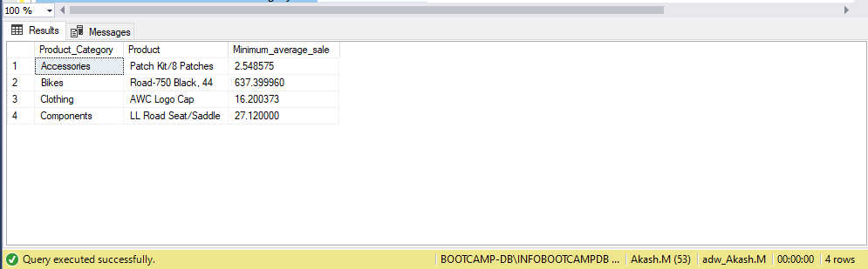

Q19A: ANS:

SELECT TOP 25 SalesOrderDetail.ProductID

INTO CustomProductID_AkashM

FROM Production.Product Product

JOIN Sales.SalesOrderDetail SalesOrderDetail

ON Product.ProductID = SalesOrderDetail.ProductID

GROUP BY SalesOrderDetail.ProductID

SELECT * FROM CustomProductID_AkashM

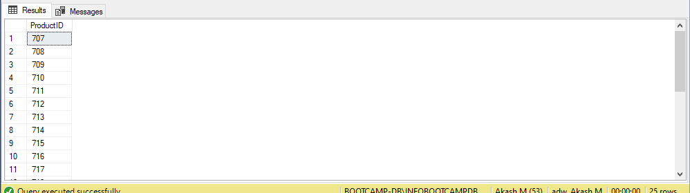

Q19B: ANS:

ALTER TABLE CustomProductID_AkashM

ADD ProductName VARCHAR(50)

UPDATE A

SET A.ProductName = Product.Name

FROM CustomProductID_AkashM A

JOIN Production.Product Product

ON Product.ProductID = A.ProductID

SELECT * FROM CustomProductID_AkashM

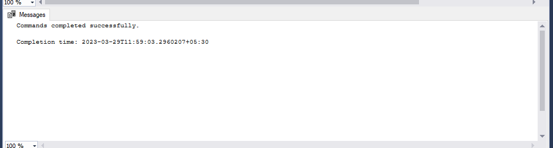

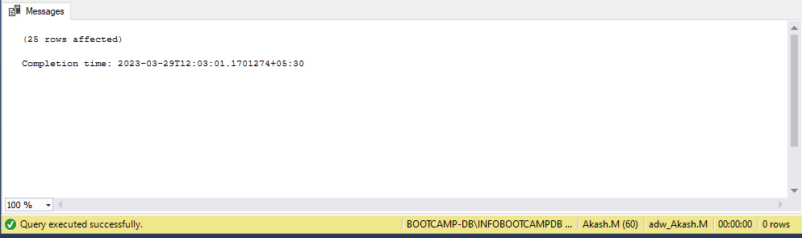

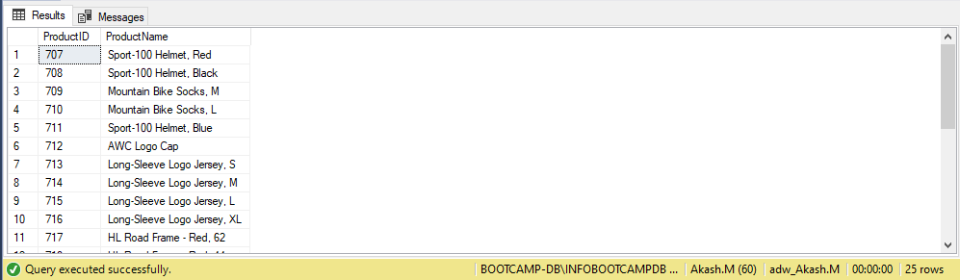

Q20: ANS:

SELECT * INTO SalesOrderDetail_AkashM

FROM Sales.SalesOrderDetail

WHERE OrderQty <= 10

or OrderQty >= 30

SELECT * FROM SalesOrderDetail_AkashM

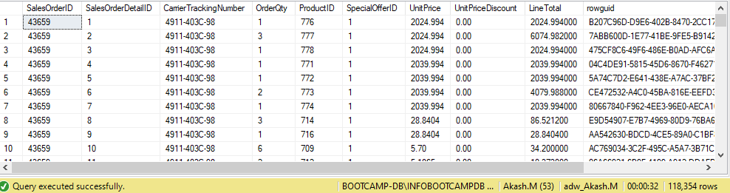

Q21: ANS:

CREATE TABLE SalesDetails_AkashM (CategoryID INT, SubcategoryID INT ,

Category VARCHAR (40), SubCategory VARCHAR (40), Total_Revenue2003 INT, Total_Revenue2004 INT)

WITH data_2003 (pc,psc,a,b,c) -- to store revenue generated in 2003

AS

(SELECT ppc.ProductCategoryID AS pc,

ppsc.ProductSubcategoryID AS psc,

ppc.Name AS a,

ppsc.Name AS b,

SUM(LineTotal) AS c

FROM Sales.SalesOrderHeader ssoh

JOIN Sales.SalesOrderDetail sso

ON ssoh.SalesOrderID=sso.SalesOrderID

JOIN Production.Product pp

ON sso.ProductID = pp.ProductID

JOIN Production.ProductSubcategory ppsc

ON pp.ProductSubcategoryID= ppsc.ProductSubcategoryID

JOIN Production.ProductCategory ppc

ON ppsc.ProductCategoryID= ppc.ProductCategoryID

WHERE ssoh.OrderDate like '%2003%'

GROUP BY ppc.ProductCategoryID, ppsc.ProductSubcategoryID ,ppc.Name,ppsc.Name),

data_2004 (pc,psc,a,b,c) -- to store revenue generated in 2004

AS

(SELECT ppc.ProductCategoryID AS pc,

ppsc.ProductSubcategoryID AS psc,

ppc.Name AS a,

ppsc.Name AS b,

SUM (LineTotal) AS c

FROM Sales.SalesOrderHeader ssoh

JOIN Sales.SalesOrderDetail sso

ON ssoh.SalesOrderID=sso.SalesOrderID

JOIN Production.Product pp

ON sso.ProductID = pp.ProductID

JOIN Production.ProductSubcategory ppsc

ON pp.ProductSubcategoryID= ppsc.ProductSubcategoryID

JOIN Production.ProductCategory ppc

ON ppsc.ProductCategoryID= ppc.ProductCategoryID

WHERE ssoh.OrderDate like '%2004%'

GROUP BY ppc.ProductCategoryID, ppsc.ProductSubcategoryID ,ppc.Name,ppsc.Name)

INSERT INTO SalesDetails_AkashM

SELECT data_2003.pc,

data_2003.psc,

data_2003.a,

data_2003.b,

data_2003.c AS revenue1,

data_2004.c AS revenue2

FROM data_2004

FULL OUTER JOIN data_2003

ON data_2004.psc= data_2003.psc

SELECT * FROM SalesDetails_AkashM

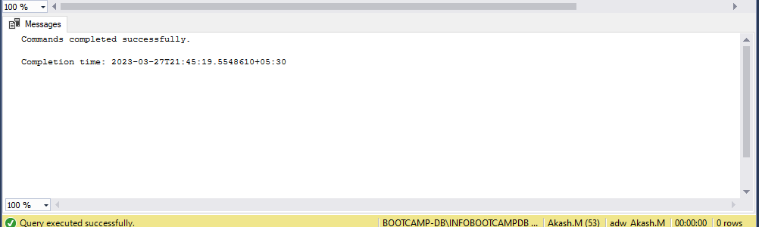

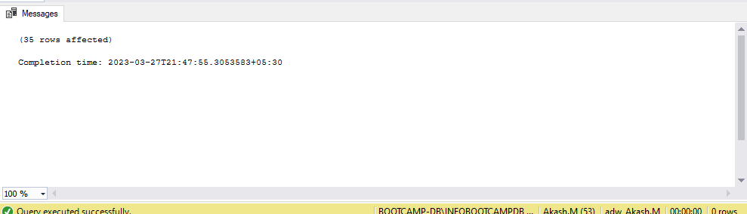  
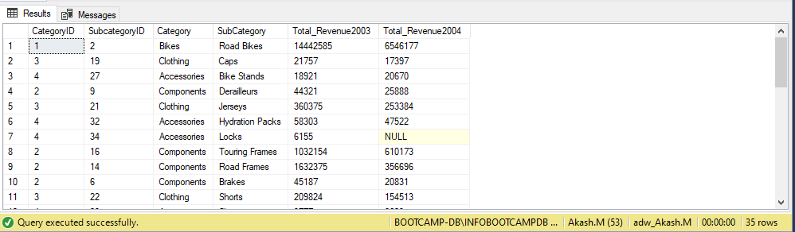

Q22A: ANS:

SELECT *

INTO Employee_AkashM

FROM HumanResources.Employee e

ALTER TABLE Employee_AkashM

ADD Salary NUMERIC (38 , 4)

UPDATE a

SET a.Salary = SalesPerson.SalesYTD

FROM Employee_AkashM a

JOIN HumanResources.Employee Employee

ON a.EmployeeID = Employee.EmployeeID

JOIN Sales.SalesPerson SalesPerson

ON Employee.EmployeeID = SalesPerson.SalesPersonID

SELECT * FROM Employee_AkashM

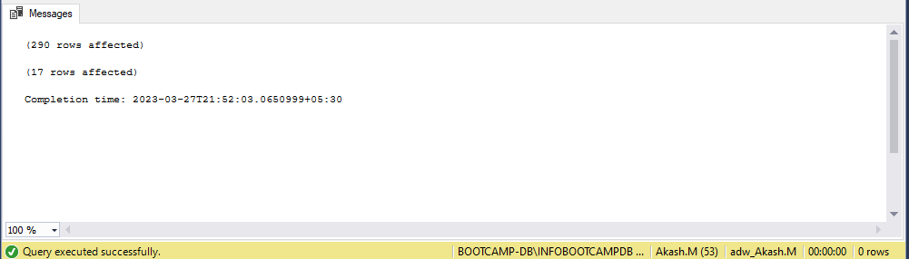

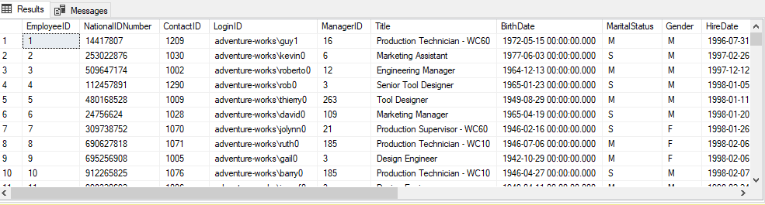

Q22B: ANS:

UPDATE a

SET Salary = (SELECT CASE

WHEN Gender = 'M' THEN Salary * 1.17

WHEN Gender = 'F' THEN Salary * 1.20

END

FROM Employee_AkashM t

WHERE a.EmployeeID = t.EmployeeID )

FROM Employee_AkashM a

SELECT * FROM Employee_AkashM

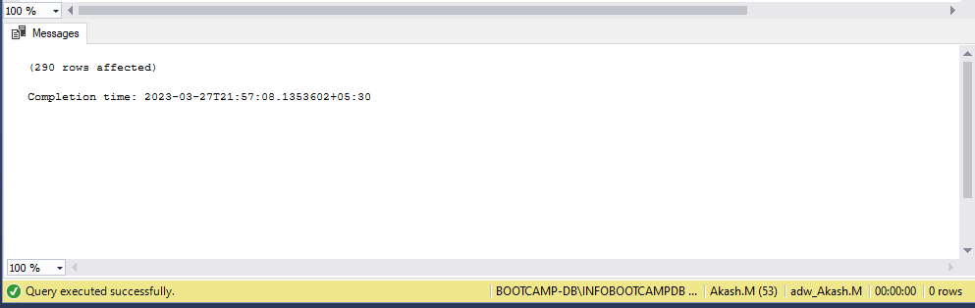

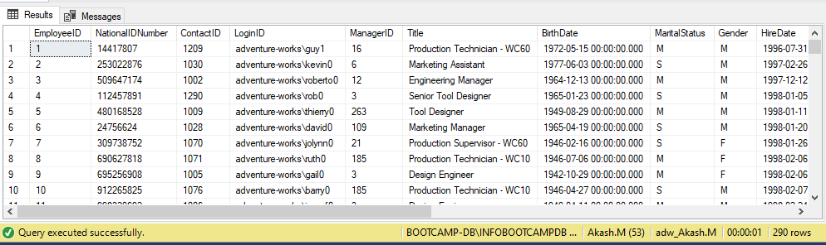

Q23: ANS:

SELECT *

INTO CopyProduct

FROM Production.Product

Update CopyProduct

SET Name = REPLACE(

REPLACE(

REPLACE(

REPLACE(

REPLACE(

REPLACE(

REPLACE(Name, '-', ''), ',', ''), '/', ''),'@',''),'$',''),'&',''),'*','')

FROM CopyProduct

SELECT * FROM CopyProduct

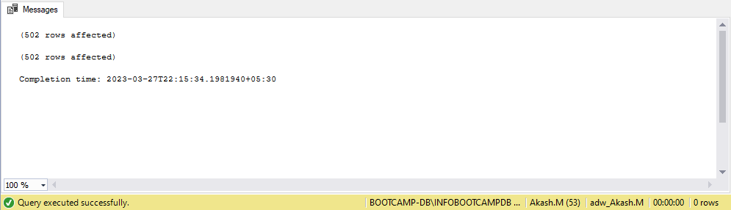

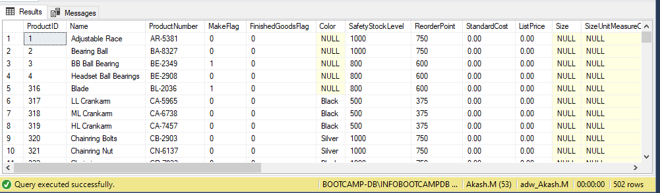

Q24: ANS:

SELECT * INTO SalesOderHeader_AkashM

FROM Sales.SalesOrderHeader

WITH Swak AS (

SELECT ROW_NUMBER () OVER( ORDER BY SalesOrderID) AS RowNumber

FROM SalesOderHeader_AkashM)

DELETE FROM Swak

WHERE RowNumber like '%00'

SELECT * FROM SalesOderHeader_AkashM

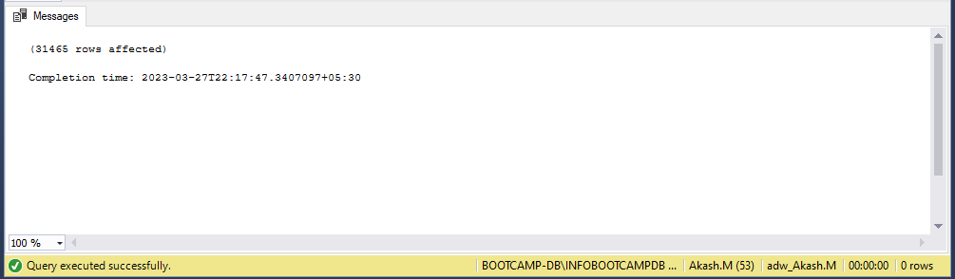

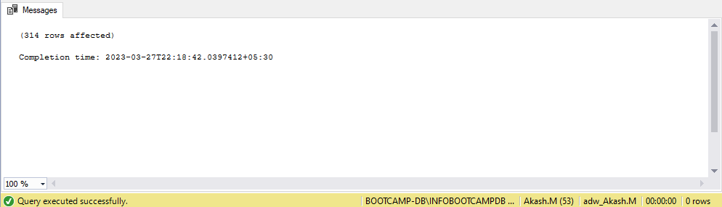

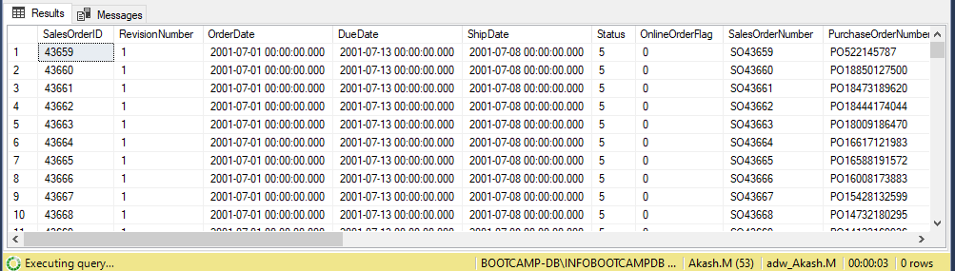

Q25: ANS:

SELECT *

INTO SalesOderDetail_AkashM

FROM Sales.SalesOrderDetail

;WITH CTE

AS (SELECT ROW_NUMBER() OVER (

PARTITION BY ProductID

ORDER BY ProductID

) DUPLICATE

FROM SalesOderDetail_AkashM)

DELETE FROM CTE

WHERE DUPLICATE > 1

SELECT * FROM SalesOderDetail_AkashM

